Scientific Investigations and Thinking

Science is the systematic study of the structure and behavior of the physical and natural world through observation and experimentation.

- Observation involves carefully watching something and taking notes about the event in order to gain information.
- Experimentation involves changing something in a situation in the expectation that the change will provide more information about the nature of the situation.

Science must be guided by natural law and must be testable against the observable world. Its conclusions are falsifiable. Falsifiability does not mean that the conclusion is false, rather it means that if it is false, then observation or experiment will at some point demonstrate its falsehood.

Science seeks to avoid inference. To infer means to draw either a conclusion with only partial evidence or a second conclusion based on the first conclusion without actually testing the accuracy of the second conclusion. For example, one could infer that, because ice floats in water, it will float in any liquid. Experimentation would reveal that, although ice floats in many liquids, there are a number of liquids it will sink in.

In this lab, students will explore the following topics:
- The Language of Science
- The Scientific Method
- Data Collecting, Processing, Presenting, and Interpreting

Part 1: The Language of Science

One of the main reasons students find the study of science challenging is that the words are difficult to write, spell, and read. Scientific vocabulary is, in some respects, a language unto itself. It is a hodgepodge of prefixes, root words, and suffixes that have been borrowed from other languages, especially Latin and Greek.

The good news is that these prefixes, root words, and suffixes have specific meanings. Learning the meanings of these word fragments will make it much easier to understand scientific vocabulary. On the next page is a list of many of the common word fragments used by scientists. Use that list to translate the meanings of the following scientific words.

Word | Meaning | Word | Meaning | Word | Meaning
a or an | not, non, without | epi | on, upon | mono | one, single
aero | needing oxygen or air | gastro | stomach | morph | form
amphi | both, doubly | genesis | origin, beginning | multi | many
angio | vessel | gymno | naked | phage | to eat
anther | flower, male | hemo | blood | philia | like, love
anti | against | hepatic | liver | phobia | dislike, fear
aqua | water | herba | plants | photo | light
arche | beginning, origin | hetero | different, other | phyll | leaf
arthro | joint | homo | alike, similar, same | phyte (phyta) | plant
auto | self | hydro | water | plasm | form
bi | two, twice, double | hyper | Above, excessive | pod (poda) | foot or feet
bio | life, living | hypo | below | poly | many
carne | flesh | intra | within, inside | proto | primitive, first
cephal | head | itis | inflammation of | sperm | seed
chloro | green | lateral | side | sub | lesser, below
cide | killer, kill, killing | logy | study of | synthesis | to make
cyto | cell | lys, lysis | break down | taxy (taxo) | arrangement
derm | skin | macro | large | therm | heat
di | two, double | meso | middle | troph | eat, consume
ecto (exo) | outer, external | meta | after, beyond | vore | swallow, devour
endo | inner, inside | meter | measurement | wort | plant or herb
endo | internal | micro | small | zoo, zoa | animal

1. Zoology __________________________________________________________
2. Protozoa __________________________________________________________
3. Spermatogenesis ___________________________________________________
4. Insecticide _________________________________________________________
5. Bilateral ___________________________________________________________
6. Endotherm _________________________________________________________
7. Ectotherm __________________________________________________________
8. Arthropod ___________________________________________________________
9. Gastropoda__________________________________________________________
10. Amphibios (amphibian) ________________________________________________
11. Hypothermia ______________________________________________________
12. Metamorphosis ______________________________________________________
13. Herbivore _________________________________________________________
14. Carnivore _________________________________________________________
Part 2: The Scientific Method

The scientific method is a body of techniques for investigating natural phenomena, acquiring new knowledge, or correcting and integrating previous knowledge. The scientific method is a stable investigation tool that has characterized natural science since the 17th century. Because science builds on previous knowledge, it consistently improves our understanding of the world.

To be termed scientific, a method of inquiry must be based on empirical and measurable evidence. Scientists seek to let reality speak for itself, supporting a hypothesis when the hypothesis’s predictions are confirmed and challenging a hypothesis when its predictions prove false. Scientific inquiry is intended to be as objective as possible in order to reduce biased interpretations of results. Another basic expectation is that scientists will document, archive, and share all data and methodology so other scientists can scrutinize the experimental design and reproduce and verify the experimental results.

Scientific researchers propose hypotheses as explanations of phenomena and design experimental studies to test these hypotheses through predictions that can be derived from them. These steps must be repeatable, to guard against mistake or confusion in any particular scientist.
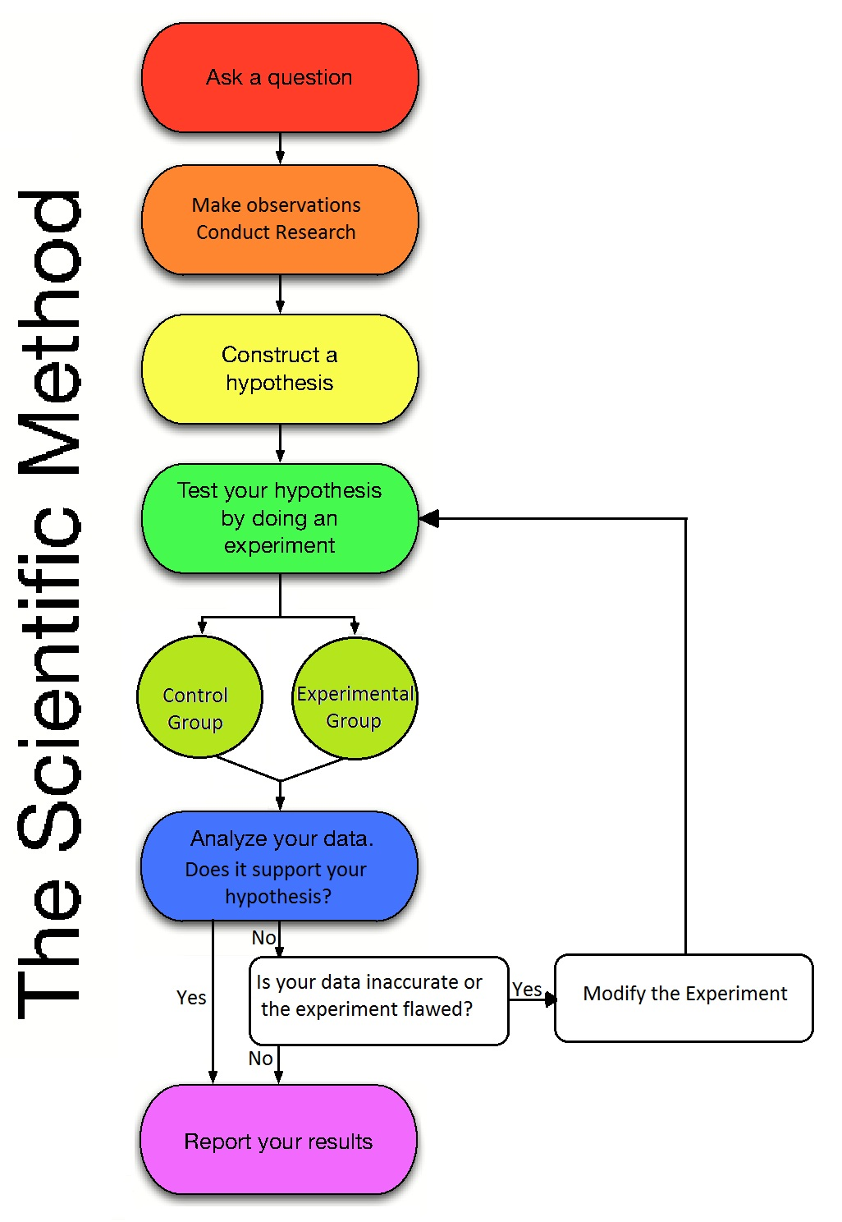
A well-designed experiment contains the following things:
- A clearly stated, testable hypothesis.
- An experiment that consists of variables, invariables, experimental groups, and control groups.
  - Independent Variable – What is being varied during the experiment. What the investigator thinks will affect the dependent variable.
  - Dependent Variable – What will be measured. What the investigator thinks will be affected during the experiment.
  - Invariables – things held the same for all study organisms.
  - Control group – the study organisms that are not subjected to the independent variable.
  - Experimental group(s) – the study organisms that are subjected to the independent variable.
- Careful collection of appropriate data
- Data analysis
- Conclusion, based upon experimental data analysis, regarding the validity of the hypothesis

Let us consider the following example. We have been assured that Brand X plant food is good for plants and promotes their growth. The instructions say that the plant food should be used every 4th watering. This leads us to the following hypothesis: “If some Brand X plant food is good for plants, then more would probably be better for plant growth.” To conduct an experiment to test this hypothesis, we would need to account for the following:
- Independent Variable – the quantity of Brand X plant food given to our test plants. Plants will receive Brand X plant food solution at the following levels:
  - Every watering
  - Every other watering
  - Every third watering, etc.
- Dependent Variable – what will be measured (data collection). We will measure what we think will be effected during the experiment. This would depend upon the purpose of our experiment.
A florist would be more interested in producing a showy plant for sale.
A nutritionist would be more interested in the nutritional value of the plant represented by the dry weight.
A plant physiologist might be interested in the photosynthetic tissue quantity versus the actual biomass of the plant which would require a correlation between the leaf surface area and dry weight.
Depending on our purpose, we need to collect some or all of the following data:
- Height of plants  - Total leaf surface area  - Circumference of base of stalk | - Wet weight of plant  - Dry weight of plant
- Invariables – all other conditions will need to remain constant for all plant groups. This would include amount of light, temperature, type of soil, wind, humidity, age at the start of the experiment, genetic composition, etc.
- Control Group – one set of plants will receive plain water only.
- Experimental Groups – the plant groups that will receive an assigned schedule for watering with Brand X plant food.

Part 3: Data Collecting, Processing, Presenting, and Interpreting

After planning and conducting a well-designed experiment, you must collect the data and process it in a way that will honestly reveal whether your hypothesis was right or wrong. Reminder: data speaks for itself and is neutral. It is unethical to ignore, discard, modify or distort the data to fit your own desires (bias). When the data suggests the hypothesis is incorrect, the investigator should review the experiment to be sure it was designed to test the hypothesis. If the design is good, then rerun the experiment. If the results are again the same, then the hypothesis is probably incorrect. On the other hand, if the data support the correctness of the hypothesis, repeat the experiment exactly as before to confirm the validity of the hypothesis.
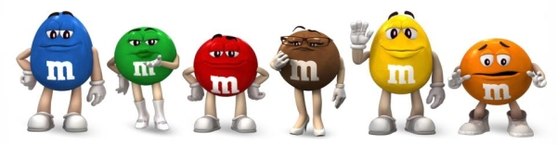
Scientific Method with M&M’s: An Edible Science Experiment

I love M&M’s. I don’t think it’s possible to know too much about them. Often, while eating a pack, I’ll wonder how they’re made and how the colors are distributed. M&M’s are, except for the color of the candy shell, all the same.
I’d heard that M&M’s were mixed to specific color ratios. However, when I checked the next few packages of M&M’s that I ate, I found that the color ratios varied significantly from package to package. This made me wonder if, in any production run, they produce the stated percentage of each color and then just fill the packs off a conveyor line or some other weight-based method. This would mean that any single package could be way off from the stated percentage; but analyze the counts over a large number of packages, and they should converge towards the stated percentages. A well-designed experiment could answer this burning question for me.

Background Research
I started my research at the M&M’s website. Sadly, it no longer posts the proportions of colors found in bags of M&M’s. After making an inquiry, I received this response in the fall of 2008.
Our color blends were selected by conducting consumer preference tests, which indicate the assortment of colors that pleased the greatest number of people and created the most attractive overall effect.

On average, our mix of colors for M&M'S CHOCOLATE CANDIES is:
M&M'S MILK CHOCOLATE:
24% cyan blue, 20% orange, 16% green, 14% bright yellow, 13% red, 13% brown.

Each large production batch is blended to those ratios and mixed thoroughly. However, since the individual packages are filled by weight on high-speed equipment, and not by count, it is possible to have an unusual color distribution.

Experimental Design
I thought about taking a random sampling of packs by grabbing many different packs from different locations, but I ruled this out because it was entirely possible that I would just get the packages that were way off the stated percentages. In addition, they would all be from different production runs and that alone would skew the numbers a bit. To get a true representative sampling, I decided to purchase a bag of the “fun-sized” packages to assure that all the packages inside came from the same production run.
I realized that I needed to count the total number of M&M’s in each package and then count the number of M&M’s of each color. I would need to calculate the percentage of each color per package. Then I would need to combine the sums of each color in all the packages of the “fun sized” bag and calculate that percentage. I was dying to know two things:
- Do all individual packages meet the color proportions described by the M&M’s company?
- If the individual packages don’t meet that expectation, would the bag as a whole meet the M&M’s color ratio?
I realized this would require a lot of counting, and that I needed to recruit some assistant scientists. I decided that I should bring this experiment to the college, where my sugar-deprived students would enjoy counting, and later consuming, the M&M’s.

Objectives
This fun activity is designed to help students learn to follow the steps of the scientific method. Students will do the following:
- Follow the steps of the scientific method to solve a problem.
- Record team data in a table or histogram.
- Construct a graph that shows the combined results of the investigation.
This activity is further designed to meet the following core objectives:
- Critical thinking skills – Students will make an inquiry and then evaluate, synthesize and analyze information.
- Communication skills – Students will communicate individual data either orally or visually (through a table or graph) to the class in order to gather classroom data.
- Empirical and Quantitative skills – Students will apply the scientific method to their inquiry and use mathematical concepts to analyze their data.
- Teamwork – Students will work in teams to gather team data that will be used to support the shared purpose of analyzing combined classroom data.
Furthermore, this activity enables students to demonstrate the following student learning outcomes.
- Describe the reasoning processes applied to scientific investigations and thinking.
- Be able to apply scientific reasoning to investigate questions, and utilize scientific tools such as microscopes and laboratory equipment to collect and analyze data.
- Communicate effectively the results of investigations.
- Use critical thinking and scientific problem-solving to make informed decisions in the laboratory.
Each team of 2 -3 students formulates a hypothesis predicting which color of M&M is the most abundant. Subsequently, students test their hypothesis by examining the candies and recording their observations in their lab report. Students will graph their results in a table and histogram. Finally, students will then compare their individual data to pooled classroom data. They will graph these results in a table and a line graph. Students will determine which graph is the most effective format for communicating their findings.
Scientific Method with M&M’s: An Edible Science Experiment
Lab Report

TEAM MEMBERS:  ___________________________________  ___________________________________  ___________________________________ | 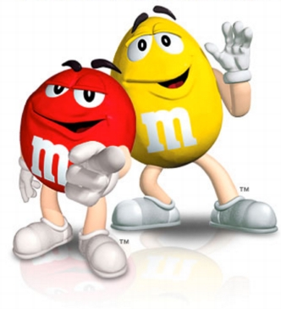
INTRODUCTION:
In this activity, you will follow the steps of the scientific method to discover how many candies of each color are in one bag of M&Ms. This will show you how scientists record data on charts, make graphs, and draw conclusions.
Do not eat any of the candies until you are permitted, because it will affect your results. Do not open the bag until you are instructed to do so.

OBJECTIVES:
1. Follow the steps of the scientific method to solve a problem.
2. Record data in a table and histogram (bar chart).
3. Present team data to class.
4. Construct a graph that shows the results of the pooled classroom data and investigation.

MATERIALS:
1 bag of “fun-sized” M&Ms per lab – one package will be used per team of 2-3 students
Colored pencils to match M&M colors
Pencil
Calculator

DIRECTIONS:
1. State the problem: (Hint – What are you trying to find out?)
_______________________________________________________________________
_______________________________________________________________________

2. Gather information. When Mrs. Estlack conducted background research, what did she find was supposed to be the color ratio in M&M’s milk chocolate candies?
_______________________________________________________________________
Do you think your packet will have exactly that ratio?_____________________________
Why / why not? __________________________________________________________
Do you think the pooled data of the classroom will be different than your ratio? ________
If yes, how will the classroom data vary from the ratio in your packet? _______________
_______________________________________________________________________
Which color do you think is most common in your packet? _________________________
3. Form a hypothesis. Write a statement that tells how many candies you think will be in
the bag and how many there will be of each color. (Remember, the total number of
candies must equal the sum of candies of each color.)
_______________________________________________________________________
_______________________________________________________________________
_______________________________________________________________________
4. Experiment! Open the bag of candies. No eating yet! Sort the candies by color.

5. Record and analyze data.
- Record the numbers of each of the candy colors in the data table below.
- Calculate the percent of each candy color in the bag and record it in the data table.
- Percentage = (# of candies of one color / total # of candies in the bag) x 100
- Quantity Expected = (Expected color ratio) (total # of candies in the bag)
- Difference = # candies of that color in bag – expected quantity of that color

 | Color Distribution in Your Bag of M&M’s
 | Blue | Orange | Green | Yellow | Red | Brown | Total
Quantity of M&M’s colors in your bag
Percentage of each color in your bag |  |  |  |  |  |  | 100%
Expected Color Ratio | 24% | 20% | 16% | 14% | 13% | 13% | 100%
Quantity Expected |  |  |  |  |  |  | --------
Difference |  |  |  |  |  |  | --------

6. Use this data to make a histogram (bar graph) below.
- Label the horizontal axis (x-axis or abscissa) with the colors of the candies.
- Label the vertical axis (y-axis or ordinate) with the numbers from 1 to 6.
- Color the bars the same colors as the candies.
- Give your bar graph an appropriate title.

7. Present your team data to the class so that pooled classroom data may be obtained.

8. Record pooled class data below:
- Mean – the average # of M&M’s of a particular color
- Mode – the most frequent quantity of a particular color of M&M’s in the packs

Classroom Color Distribution - Snack-Size M&M’s Packs
Group # | Blue | Orange | Green | Yellow | Red | Brown | Total
1
2
3
4
5
6
7
8
9
10
11
12
13
14
15
16
Quantity Observed
(Totals)
Percentage Observed
Expected color ratio | 24% | 20% | 16% | 14% | 13% | 13% | 100%
Quantity expected |  |  |  |  |  |  | ---------
Difference
Mean
Mode
Maximum in pack
Minimum in pack

9. Use the pooled classroom data to make a line graph below.
- Label the horizontal axis (x-axis or abscissa) with the colors of the candies.
- Label the vertical axis (y-axis or ordinate) with the numbers from 1 to 80; in intervals of 5.
- Use a different color to graph the following data lines.
  - Expected quantity of each color
  - Observed quantity of each color
- Create a legend to explain what the colored lines represent
- Give your bar graph an appropriate title.

Legend

CONCLUSIONS:

1. Did your team data support your hypothesis? (Remember that a good hypothesis is not a wild guess. It is a testable prediction. The actual experiment is the test that proves whether or not the hypothesis is correct.)

2. Why or why not?

3. Was your team data or the pooled classroom data closer to the expected color ratio?

4. Based on your observations, why do you think scientists do repeated trials in their experiments?

5. Do you think that our classroom results can be generalized to predict the most common color of M&M’s in other bags of these candies? Why or why not?

6. We presented our data through 3 types of graphs (tables, histograms, and line graphs). Which do you feel is the most effective format for communicating our findings? Why?

