Mendel’s Laws: Their Application to Solving Genetics Problem

Objectives
This lab activity is designed to teach students how to solve classic genetics problems using Mendel’s genetic laws and the Punnett square.
This activity is further designed to meet the following core objectives:
- Critical thinking skills – Students will make inquiries into inheritance of traits and then evaluate and analyze genetics problems.
- Communication skills – Students will communicate team solutions both orally and visually to the class as they teach their classmates how to solve an assigned team problem.
- Empirical and Quantitative skills – Students will apply the Mendelian genetics laws and the Punnett square to quantify the outcome of their assigned genetic problem.
- Teamwork – Students will work in teams of 2 to 4 to solve an assigned genetics problem.
Furthermore, this activity enables students to demonstrate the following student learning outcomes.
- Describe the reasoning processes applied to scientific investigations and thinking.
- Identify the principles of inheritance and solve classical genetic problems.
- Describe modern evolutionary synthesis, natural selection, Mendelian inheritance, micro and macroevolution, and speciation.
- Be able to apply scientific reasoning to investigate questions, and utilize scientific tools such as microscopes and laboratory equipment to collect and analyze data.
- Communicate effectively the results of investigations.
- Use critical thinking and scientific problem-solving to make informed decisions in the laboratory.

Instructors will demonstrate how to apply Mendelian genetics laws and the Punnett square to solve genetics problems. Afterward, students will work in teams of 2 - 4 students and be assigned a genetics problem to solve. After all student teams have solved their problems, they will teach the class how to solve the problem. Their classmates will write down the steps to solution of each problem in their lab handouts.

Contents: | Page Number
Core Objectives & Student Learning Outcomes | 1
Mendel’s Genetic Laws | 2
Steps to Solving Genetics Problems | 2
Monohybrid Problems | 3 – 4
Dihybrid Problems | 5 – 6
Incomplete Dominance Problems | 7
Sex-Linked Traits Problems | 7
Student Practice Problems | 8 – 16
Mendel’s Genetic Laws
1. Alleles control an inherited characteristic & exist in individuals in pairs (You inherit one member of the pair from your father & one member of the pair from your mother). The two alleles of a pair are the same in homozygous individuals. The two alleles of the pair differ in heterozygous individuals. The genotype is the allele combination that produces a character state. The phenotype is the visible, physical trait.

2. LAW OF DOMINANCE: Whenever the two alleles of a pair in a given individual differ, only one, the dominant one will be expressed. The dominant allele indicates the appearance of heterozygotes. One allele is said to be dominant over another if a heterozygous individual for that allele has the same appearance as an individual homozygous for it. The recessive allele’s phenotype effects are masked in heterozygotes by the presence of a dominant allele.

3. LAW OF SEGREGATION OF ALLELES: When the gametes (egg & sperm) are formed by an individual, only one member of each allele pair is included in a gamete. Recall that gametes are haploid. When the parent generation produces gametes (eggs or sperm), each gamete will receive only one allele for a given trait. When the egg and sperm unite during fertilization, the resulting embryo receives one allele for the trait from the egg and one allele for the trait from the sperm, restoring the allele pair and the diploid condition.

4. LAW OF INDEPENDENT ASSORTMENT: All of the possible kinds of gametes that can be formed, will be formed in equal proportions. Alleles for different traits are inherited independently of each other so long as they are located on different homologous gene pairs.

Steps to Solving Genetics Problems

1. READ the problem
2. Write down what you know
a. Record the possible phenotypic outcomes
3. Assign letters for the alleles
a. Use a capital letter for the dominant trait
b. Use a lower case letter for the recessive trait
4. Determine the genotypes involved
5. Make gametes (sex cells – each gamete will carry only ONE allele for a trait, not both)
6. Solve using a Punnett Square
7. Reread the question & make sure that you have answered it

Single Trait Problems (Monohybrid Crosses)

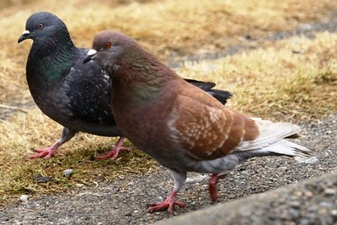  Red pigeon is in front of the more commonly-colored brown pigeon.  Photo source: naturetales.blogspot.com | SAMPLE PROBLEM: The allele for red feather color in pigeons, R, is dominant to the allele for brown feathers, r. A red pigeon who had a red parent and a brown parent is mated with a brown pigeon.  - What are the genotypes of the two pigeons being mated?  - Identify the gametes produced by each of the pigeons being mated.  - What proportion of the F₁ progeny would be expected to have brown feathers?
STEPS TO THE SOLUTION:

1. Write down what you know
Possible phenotypes: RR = red feathers; Rr = red feathers; rr = brown feathers

Grandparent Pigeons – Red X Brown
(Genotypes) R __ r r

Parent Pigeons - Red X Brown
(Genotypes) R __ r r

F₁ (first filial or offspring or babies) --

2. Determine the genotypes involved
We know that the brown parent must be homozygous, or rr. Otherwise, it would appear red in color. The red parent is a little trickier. That parent could be either homozygous or heterozygous. Rereading the problem, we see that this parent was produced from the crossing of a red and a brown pigeon. In other words we are at the very least crossing R_ X rr to get the red parent. In order for the offspring of this cross to be red it must have one dominant allele that it will inherit from its red parent. We know that the brown pigeon must give all of its offspring the recessive allele. Thus, the red parent pigeon in this problem must have a heterozygous genotype for color, or Rr.

Now we can record the parent’s genotypes.

Grandparent Pigeons – Red X Brown
(Genotypes) R __ rr

Parent Pigeons - Red X Brown
(Genotypes) Rr rr

F₁ (first filial or offspring or babies) --

3. Make gametes (sex cells – each gamete will carry only ONE allele for a trait, not both)
The brown pigeon has a genotype of rr. Thus all of the gametes it will produce will have the r allele. The red pigeon has a genotype of Rr. Thus it will produce gametes with R alleles and gametes r alleles in equal proportions.

Parent Pigeons | Red X | Brown
(Parent Genotypes) | Rr | rr
Gametes Produced | 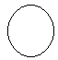

4. Solve using a Punnett Square

Gametes | R | r
r
r

Genotypic ratio of the F₁ generation = 2 Rr : 2 rr.
Phenotypic ratio of the F₁ generation = 2 red : 2 brown.

6. Reread the question & make sure that you have answered it

a. The red parent’s genotype is Rr. The brown parent’s genotype is rr.
b. The red parent produces 2 types of gametes. Half carry the allele of red & half carry the allele for brown.
The brown parent produces only one type of gamete. All of its gametes carry the allele for brown.
c. We would expect half of the offspring to have brown feathers.
Two Trait Problems (Dihybrid Crosses)

SAMPLE PROBLEM: In humans, brown eyes are dominant to blue eyes. Also brown hair (brunette) is dominant to red hair. Imagine that a man who is heterozygous for both traits marries a woman who is heterozygous for both traits.
- What are the genotypes of the parents?
- What would be the phenotypic ratio of their potential children?

1. Write down what you know

Parents - MAN X WOMAN
heterozygous brown eyes heterozygous brown eyes
heterozygous brunette heterozygous brunette

2. Assign letters for the alleles:
Brown eyes are dominant to blue eyes. We will use the letter b for these alleles. Brown is dominant, so it should be B. Blue is recessive, so it should be b.
We know that brunette hair color is dominant to red hair. We’ve already used the letter b, so we will use the letter r for these alleles. Brunette is dominant, so it should be R. Red hair is recessive, so it should be r.

3. Determine the genotypes involved
Remember that the parents are heterozygous for both traits.

Parents - MAN X WOMAN
heterozygous brown eyes heterozygous brown eyes
heterozygous brunette heterozygous brunette
(Genotypes) B b R r B b R r

4. Make gametes (Sex cells – Remember that each gamete will carry only ONE allele for a trait, not both. However, since this is a two-trait or dihybrid problem, the gametes will carry ONE allele for eye color and ONE allele for hair color.)

HINT: Do an allele cross to make sure you get one of every possible type of gamete! (Remember FOIL)

 | F(irst) | O(uter) | I(nner) | L(ast)
Parents’ Genotypes | 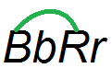 | 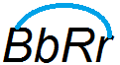 | 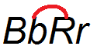 | 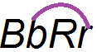
Gametes | BR | Br | bR | br

5. Solve using a Punnett Square

Gametes

You have just written all of the genotypes possible for their children! Let’s figure out what their phenotypes will be.

a) To have the brown eyes, brown hair phenotype, a child must have at least B__ R__. There are four ways to satisfy this minimum. Locate each of the following genotypes in the Punnett square and record the number of each type:

BBRR _____ ; BbRR _____ ; BBRr ______ ; BbRr______ ; Total _______

b) To have the brown eyes, red hair phenotype, a child must have at least B_rr. Locate and record again:

BBrr ________ ; Bbrr ________ ; Total _________

c) To have the blue eyes, brown hair phenotype, a child must have at least bbR_. Locate and record again:

bbRR ________ ; bbRr ________ ; Total _________

d) To have the blue eyes, red hair phenotype, a child must have at least bbrr. Locate and record again:

bbrr _________ ; Total _________

THUS, the phenotypic ratio of the man and woman’s potential children is:
_____ brown eyes, brown hair : _____ brown eyes, red hair :
_____ blue eyes, brown hair : _____ blue eyes, red hair

Incomplete Dominance Problems

SAMPLE PROBLEM: In humans, inheritance of hair texture shows incomplete dominance. If a person inherits two alleles for curly hair, they have very curly hair (CC). If a person inherits two alleles for straight hair, they have very straight hair (C’C’). A heterozygous person (CC’), on the other hand, shows an intermediate condition, wavy hair. If a wavy-haired man married a wavy-haired woman, what percentage of their children would you expect to have curly hair?

Parents | Man X  Wavy-Haired | Woman  Wavy-Haired
(Parent Genotypes) | CC’ | CC’
Gametes Produced

Because the couple are heterozygotes, they will produce two types of gametes; C and C’. We can use this information to complete a Punnett square.
Gametes | C | C’
C
C’

What percent of their offspring should have curly hair? ______________________________

Sex-Linked Trait Problems
SAMPLE PROBLEM: In humans, red-green color blindness is a sex-linked trait. Normal color vision is due to allele C & color blindness is due to allele c. The heterozygous condition results in a carrier condition in females (they see red-green normally, but can pass the trait on to their offspring). What would be the phenotypic ratio of offspring produced by a color blind male and a carrier female?

For this problem, we have 3 possible character states:
X^{B} X^{b} = carrier female | X^{b} X^{b} = color blind female  X^{b} Y = color blind male | X^{B} X^{B}= normal female  X^{B} Y = normal male

The color blind male in this case will have genotype X^{b} Y. He will produce 2 types of gametes: X^{b} & Y. The carrier female will have genotype X^{B} X^{b}. She will produce 2 types of gametes: X^{B} & X^{b} . We can use this information to complete a Punnett square.
Gametes | X^{B} | X^{b}
X^{b}
Y
What will be the phenotypic ratio of this couple’s children? ________________________________
Let’s Practice: Students will work in teams of 2 - 4 and be assigned a genetics problem to solve. After solving their problems, the student teams will teach the class how to solve their assigned problem. Classmates will write down the steps to solution of each problem in their lab handouts.

MONOHYBRID PROBLEMS
1. Several plants with purple flowers were crossed to plants with white flowers. The seeds from the cross produced plants on which only purple flowers appeared. These purple-flower plants were then crossed to each other & the seeds from the cross produced 346 purple flowered plants & 128 white flowered plants. Illustrate the crosses involved & determine the phenotypic & genotypic ratios of the last generation of plants.
Gametes

2. In peas, long-stem (L) is dominant over short-stem (l). Give the expected phenotypic ratios for the following four crosses:
a. homozygous long X short  Phenotypic ratio: | c. heterozygous long X homozygous long  Phenotypic ratio:
  Gametes
  Gametes
b. heterozygous long X short  Phenotypic ratio: | d. heterozygous long X heterozygous long  Phenotypic ratio:
  Gametes
  Gametes
3. In humans, dimples (D) are dominant to nondimples (d). A couple who both have dimples, have a child without dimples. What must be the genotypes of the two parents? What is the probability that their next child will have dimples?
Gametes

DIHYBRID PROBLEMS

White, sphere-shaped squash  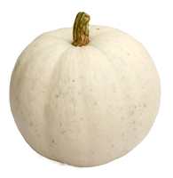  Photo source: http://www.thenibble.com/ | 4. In the summer squash, white fruit (W) is dominant over yellow (w), & disk-fruit shape (D) is dominant over sphere-shaped (d).  a. What are the phenotypes of the following squashes?  1) WWdd ___________________________________________________  2) wwDD ___________________________________________________  3) WwDd ___________________________________________________  4) wwdd ___________________________________________________  5) WwDD ___________________________________________________  b. What would be the phenotypic ratio of the offspring produced from the following cross?  WwDd X wwdd
Yellow, disk-shaped squash
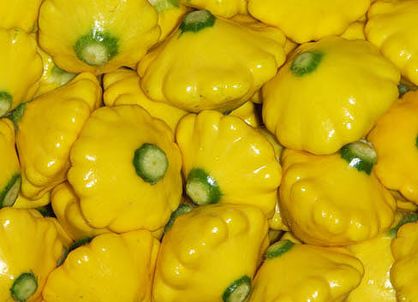
Photo source: http://www.photographsofaustralia.com/

Gametes produced by WwDd: | F(irst) | O(uter) | I(nner) | L(ast)
Gametes

Gametes produced by wwdd: | F(irst) | O(uter) | I(nner) | L(ast)
Gametes

Genotypes of offspring (F₁ generation):
Gametes

Phenotypic Ratio of F₁ generation:

______ White, Disk: ______ White, Sphere: ______ Yellow, Disk: ______ Yellow, Sphere

Black, long-haired rabbit  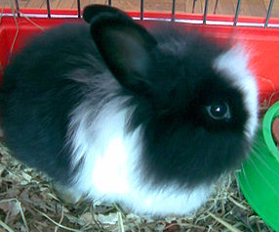  Photo source: http://upload.wikimedia.org/ | 5. In rabbits, black fur is due to a dominant allele B, and brown fur is due to its recessive allele b. Short hair is due to the dominant allele S, & long hair is due to the recessive allele s. A cross is done between a homozygous black, long-haired rabbit & a homozygous brown, short-haired rabbit.  a. What would be the genotype(s) & phenotype(s) of the F₁ generation?  b. When the F₁ offspring are allowed to breed, what will be the phenotypic ratio of the F₂ generation? | Brown, short-haired rabbit  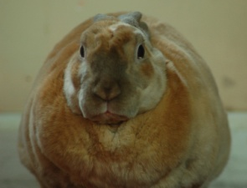  Photo source: http://farm3.static.flickr.com

Parent Rabbits |  |  | Offspring (F₁ generation)  We will cross two F₁ babies next
Phenotypes | Genotypes | Gametes  Produced | Genotype | Phenotype
Homozygous black, long-haired
Homozygous brown, short-haired

Gametes produced by F₁ generation:
F₁s’ Genotype | F(irst) | O(uter) | I(nner) | L(ast)
Gametes

Genotypes of F₂ generation:
Gametes

Phenotypic Ratio of F₂ generation:

______ Black, Short: ______ Black, Long: ______ Brown, Short: ______ Brown, Long

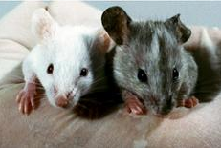  Photo source: http://media.knoxnews.com/ | 6. In mice the gene for coat color has two forms. The allele for colored coat (C) is dominant to the allele for albino (c). There are two forms for the gene controlling whiskers, as well, straight (S) is dominant to bent (s). Imagine that we had a female mouse whose mother was homozygous colored with bent whiskers and whose father was an albino that was homozygous for straight whiskers. We are going to cross this female on a male mouse that is albino and has bent whiskers.  a. What percent of their offspring will be albino?  b. What percent of their offspring will have straight whiskers?  c. What would be the phenotypic ratio of their offspring?

Female Mouse’s Parents |  |  | Female Mouse
Phenotypes | Genotypes | Gametes  Produced | Genotype | Phenotype
Homozygous colored, bent
Homozygous albino, straight

Gametes produced by Female Mouse:
Female Mouse’s Genotype | F(irst) | O(uter) | I(nner) | L(ast)
Gametes

Gametes produced by Male Mouse (albino with bent whiskers):
Male Mouse’s Genotype | F(irst) | O(uter) | I(nner) | L(ast)
Gametes

Genotypes of F₁ generation:
Gametes

Phenotypic Ratio of F₁ generation:

______ Colored, Straight: ______ Colored, Bent: ______ Albino, Straight: ______ Albino, Bent
7. In rabbit coats, spotted (S) is dominant to solid color (s) and black (B) is dominant to brown (b). A brown, spotted rabbit is mated with a solid, black one and all the offspring (the F₁ generation) are black and spotted.
a. What are the genotypes of the parents?
b. What are the genotypes of the offspring (the F₁ generation)?
b. What would be the phenotypic ratio of the F₂ generation if two of these F₁ black, spotted rabbits were mated?

Parent Rabbits |  |  | Offspring (F₁ generation)  We will cross two F₁ babies next
Phenotypes | Genotypes | Gametes  Produced | Genotype | Phenotype
Brown, spotted |  |  |  | 100% Black, spotted
Black, solid |  |  |  | 100% Black, spotted

Gametes produced by F₁ generation:
F₁s’ Genotype | F(irst) | O(uter) | I(nner) | L(ast)
Gametes

Genotypes of F₂ generation:
Gametes

Phenotypic Ratio of F₂ generation:

______ Black, Spotted: ______ Black, Solid: ______ Brown, Spotted: ______ Brown, Solid

INCOMPLETE DOMINANCE PROBLEMS
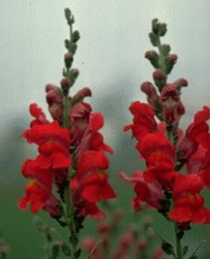  Photo source: http://www.greenearthgrowers.net/ | 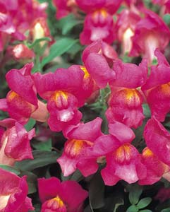  Photo source: http://www.jparkers.co.uk/ | 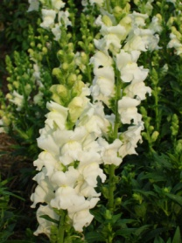  Photo source: http://www.weststarfarm.com/ | 8. In snapdragons, red flower color (W) is not completely dominant over white (W’); the heterozygous condition produces pink flowers.  What will be the result of a cross between two pink-flowered snapdragons?  Between a pink and a white one?

Parent Flowers | Pink X | Pink
(Parent Genotypes)
Gametes Produced

Genotypes of F₁ generation (offspring of pink X pink):

Gametes

Phenotypic Ratio of F₁ generation (offspring of pink X pink): ________________________________________________________________________________

Parent Flowers | Pink X | White
(Parent Genotypes)
Gametes Produced

Genotypes of F₁ generation (offspring of pink X white):

Gametes

Phenotypic Ratio of F₁ generation (offspring of pink X white): ________________________________________________________________________________

9. Two parents have wavy hair & dimples. They have a child with curly hair & no dimples. Identify the genotypes of the two parents and then determine all of the possible phenotypes that their children could have for the dimple & hair trait. (Remember that dimples is dominant to nondimples. Also the heterozygous condition in which a person inherits an allele for straight hair & an allele for curly hair results in an intermediate condition, wavy hair.)

Parents |  |  | Child
Phenotypes | Genotypes | Gametes  Produced | Genotype | Phenotype
Wavy hair, dimples |  |  |  | Curly hair, no dimples
Wavy hair, dimples |  |  |  | Curly hair, no dimples

Parents’ Genotypes (wavy hair, dimples): _____________________________________
Gametes produced by Parents:
 | F(irst) | O(uter) | I(nner) | L(ast)
Gametes

Genotypes of their offspring:
Gametes

Phenotypic Ratio of F₂ generation:

______ Curly hair, Dimples: ______ Wavy hair, dimples: ______ Straight hair, dimples:
______ Curly hair, no dimples: ______ Wavy hair, no dimples: ______ Straight hair, no dimples

10. In shorthorn cattle, the polled (hornless) condition (P) is dominant over the horned condition (p), also the heterozygous condition of red coat (W) and white coat (W’) is roan. If a homozygous polled red animal is bred to a white horned one, what will the F₁ be like? If two F₁ were crossed, what would be the phenotypic ratio of the F₂ generation?
Red Polled  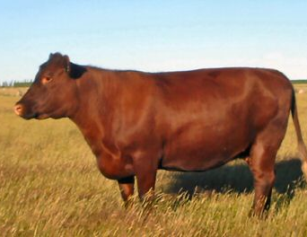  Photo source: http://www.rarebreeds.co.nz/ | Roan  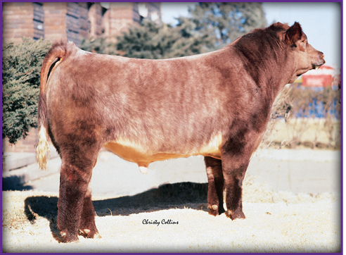  Photo source: http://www.midcontinentfarms.com/ | White Horned  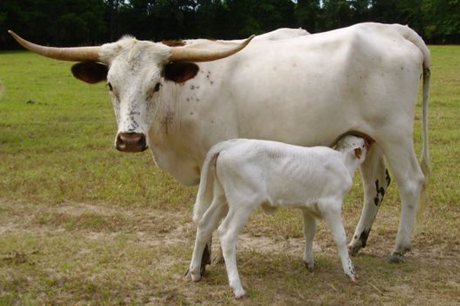  Photo source: http://www.glcattleco.com/

Parent Cattle |  |  | Offspring (F₁ generation)  We will cross two F₁ babies next
Phenotypes | Genotypes | Gametes  Produced | Genotype | Phenotype
Homozygous red, polled
White, horned

Gametes produced by F₁ generation:
F₁s’ Genotype | F(irst) | O(uter) | I(nner) | L(ast)
Gametes

Genotypes of F₂ generation:
Gametes
Phenotypic Ratio of F₂ generation:

______ Red Polled: ______ Roan Polled: ______ White Polled:
______ Red Horned: ______ Roan Horned: ______ White Horned

SEX-LINKED TRAIT PROBLEMS:

SOME PRACTICE SEX-LINKED TRAIT PROBLEMS

Calico Cat  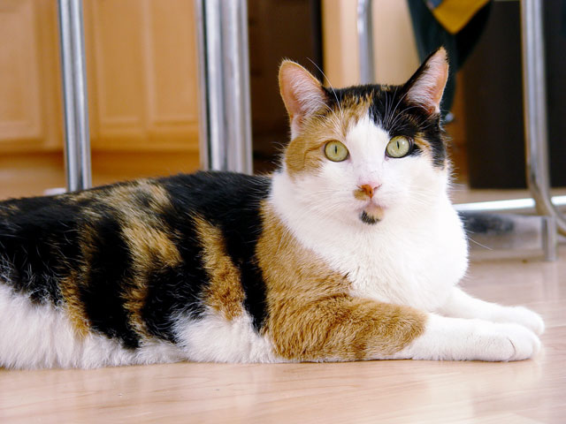  Photo source: http://www.hanne-mugaas.com/ |  | Tortoise Shell Cat  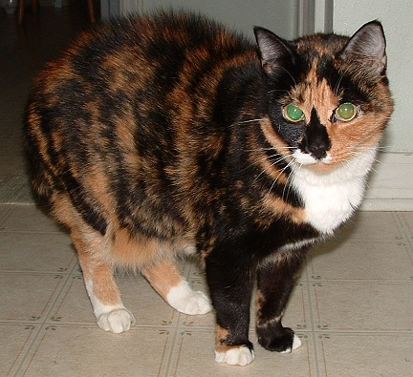  Photo source: http://www.catsarewonderful.com/
11. In cats, orange color is due to allele B’ & black color is due to allele B. The heterozygous condition (B’B) results in a color known as calico (calico is a coat pattern that is mottled in tones of black, orange, and white) in females. These alleles are known to be sex-linked. What coat color types would be expected from a cross between a black male & a calico female?

For this problem, we have 3 possible character states:
X^{B’} X^{B}= calico female | X^{B’} X^{B’} = orange female  X^{B’} Y = orange male | X^{B} X^{B} = black female  X^{B} Y = black male

Genotype of black male: _____________________________________

Gametes produced by black male: ________________________

Genotype of calico female: ____________________________________

Gametes produced by calico female: ________________________

Gametes

What will be the phenotypic ratio of their kittens? ________________________________

