Zoology – Evolution and Gene Frequencies

- __________________________ – any change in the frequency of alleles (and resulting phenotypes) in a population.

  - Individuals show genetic variation, but express the genes they have inherited.
    - Individuals do NOT evolve. Populations do.
    - _______________________________ - those individuals with good traits (for that environment) are successful and pass their genes on to the next generation.
      - This should ensure that the population becomes more fit for that environment.

  - _______________________________ - one of two or more alternative forms of a gene that arise by mutation and are found at the same place on a chromosome.
    - A change in the frequency of alleles in a gene pool indicates the presence of evolutionary change.
    - _______________________________ - the collective genetic information contained in a population of sexually reproducing organisms.

  - _______________________________ - all the animals in a particular place that could interbreed.
    - Populations evolve as gene frequencies change over time.

- The Hardy-Weinberg theorem (HW)

  - Timeline for these major events:
    - 1859 – Darwin publishes Origin of Species
    - 1856 – 1864 – Mendel conducts pea plant genetics experiments
    - 1900 – Gregor Mendel’s work is “rediscovered”
    - 1908 – Hardy and Weinberg explore genetics and evolution mathematically

  - There was a question as to whether Mendelian genetics alone could supply the necessary ingredients for evolution to occur.
    - Hardy (a mathematician) in England and Weinberg (a physicist) in Germany proposed that the process of heredity operating in isolation would not alter the genetic makeup of a population.

  - The Hardy-Weinberg theorem states that allele frequencies in a population will remain constant from generation to generation in the absences of other evolutionary influences.
    - In order for the allele frequency to stay the same, the following conditions must be met:
      - The population size must be large to prevent the change in allelic frequencies by chance alone.
      - Mating must be random.
      - Migration must not occur, as it would add or delete alleles from the gene pool.
      - Mutation must not occur, or a mutational equilibrium must exist.
    - These assumptions are typically not met in natural populations, so most populations are evolving.

  - Hardy and Weinberg’s work developed a new field of research called population genetics,

- How are allele frequencies calculated? p² + 2pq + q² = 1.0
  - This formula works for traits with 2 alleles; one dominant and one recessive.

  - p = the frequency of dominant allele (represented here by A).
q = the frequency of the recessive allele (represented here by a).

  - For a population in genetic equilibrium: p + q = 1.0
    - The sum of the frequencies of both alleles is 100% (which is 1.0)
    - p² = frequency of homozygous dominant individuals, AA
    - 2pq = frequency of heterozygous individuals, Aa
    - q² = frequency of recessive individuals, aa

Mathematical Explanation | Biological Explanation
p + q = 1.0  (p + q)² = 1.0  (p + q)(p + q) = 1.0 (remember FOIL)  p² + 2pq + q² = 1.0 | If people are AA, they must inherit:  - A from mom (frequency of that allele is p)  - A from dad (frequency of that allele is p)  - Frequency of AA in population is (p)(p) = p²  If people are Aa, one of two things happened:  - They inherited A from mom & a from dad  - Frequency in population is (p)(q)  - They inherited A from dad & a from mom  - Frequency in population is (p)(q)  - It doesn’t matter which parent they inherited their alleles from, so we can combine these outcomes.  - (p)(q) + (p)(q) = pq + pq = 2pq  If people are aa, they must inherit:  - a from mom (frequency of that allele is q)  - a from dad (frequency of that allele is q)  - Frequency of aa in population is (q)(q) = q²  We combine all of the possible outcomes to calculate the allele frequency in our population.  - p² + 2pq + q² = 100% = 1.0

  - Let’s try a practice problem: Let’s look at a sample population of pigs. The trait for coat color is controlled by two alternate alleles. The allele for black coat is recessive. What percent of the pig population is heterozygous for white coat?
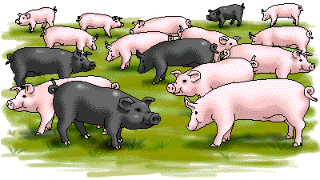

      - Step 1: Calculate q² (frequency of homozygous recessive pigs)
        - Count the # of pigs that are homozygous recessive (black) =
Count the # of pigs that are white =

        - Calculate the percent of the total population they represent. This is q².
          - q² = # black pigs / total # pigs =

      - Step 2: Find q (frequency of the recessive allele in the pig population)
        - q = √ q² =

      - Step 3: Find p (frequency of the dominant allele in the pig population)
        - The sum of the frequencies of both alleles = 100%
        - p + q = l
        - p = 1 – q
        - p =

      - Step 4: Find 2pq (the frequency of heterozygous pigs)
        - 2pq =

Let’s review our formula, just to check our work:
Frequency of Genotype in Population |  | 50%
Phenotype of Pig | Homozygous White | Heterozygous White | Black
Genotype of Pig | AA | Aa | aa
Hardy Weinberg Formula | p² | 2pq | q²
Adding our data

Remember, it should add up to 1.0.

- Let’s try another practice problem: The Hardy-Weinberg equation is useful for predicting the percent of a human population that may be heterozygous carriers of recessive alleles for certain genetic diseases.
Phenylketonuria (PKU) is a human metabolic disorder that results in mental retardation if it is untreated in infancy. In the United States, one out of approximately 10,000 babies is born with the disorder.
Approximately what percent of the population are heterozygous carriers of the recessive PKU allele?
q² = frequency of recessive individuals (have PKU) = 1/10,000 =

q = frequency of this recessive allele in the population = √q² =

(frequency of recessive allele) + (frequency of dominant allele) = 100% =1.0
p + q =1.0
p = 1.0 – q =

CARRIERS FOR PKU = 2pq =

- Why does evolution occur in populations that violate one or more of the conditions of Hardy-Weinberg equilibrium?
  - Small population sizes results in _______________________________.
    - Genetic drift occurs when chance events result in changing allelic frequencies.
    - Two types of genetic drift occur:
      - The _______________________________is seen when a small subpopulation fragments from the main population and colonizes a new habitat.
      - The few individuals that found the new population have a different allele frequency than the original population.
        - The founder effect is often seen on islands or other previously unexploited habitats
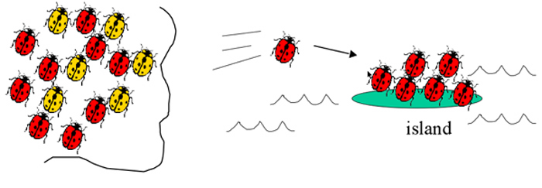
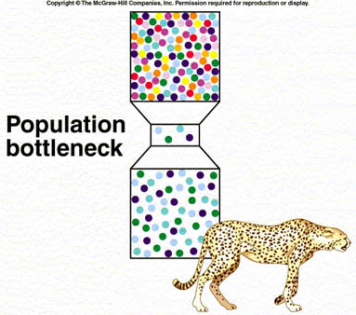
      - A ____________________________ occurs when a population is severely reduced (and hence the allelic variation is reduced) and then the population expands, with only a small amount of genetic variation.
        - Classic examples of bottlenecks are seen in the population of the Northern elephant seal and the cheetah.
  - Migration of individuals includes migration of their alleles into and out of populations, so _______________________________ negates HW equilibrium.
  - _______________________________ rates are low, random, and most mutations are harmful.
    - Mutations are the only way for entirely new genetic sequences to become established.
      - Genetic drift and migration may lead to new combinations of previously seen sequences, but no material that is truly novel for that species.
    - Thus, mutations act as a very important mechanism by which evolution occurs.
    - It is possible for a mutation to lead to a positive outcome for an organism.
      - Natural selection will cause mutations with positive effects to be strongly represented in subsequent generations.
  - Natural selection occurs when some phenotypes (individuals) survive better and leave more offspring in future generations than do other phenotypes—these differences will upset Hardy-Weinberg equilibrium and lead to evolution.
    - These relative advantages of some phenotypes produce a selection pressure.
    - Selection pressures are of several types:
      - _______________________________ selection occurs when organisms at one extreme of a phenotypic continuum are favored.
      - _______________________________ selection occurs when organisms at both extremes of a phenotypic continuum are favored.
      - _______________________________ selection occurs when organisms at the intermediate form of the phenotype are favored.
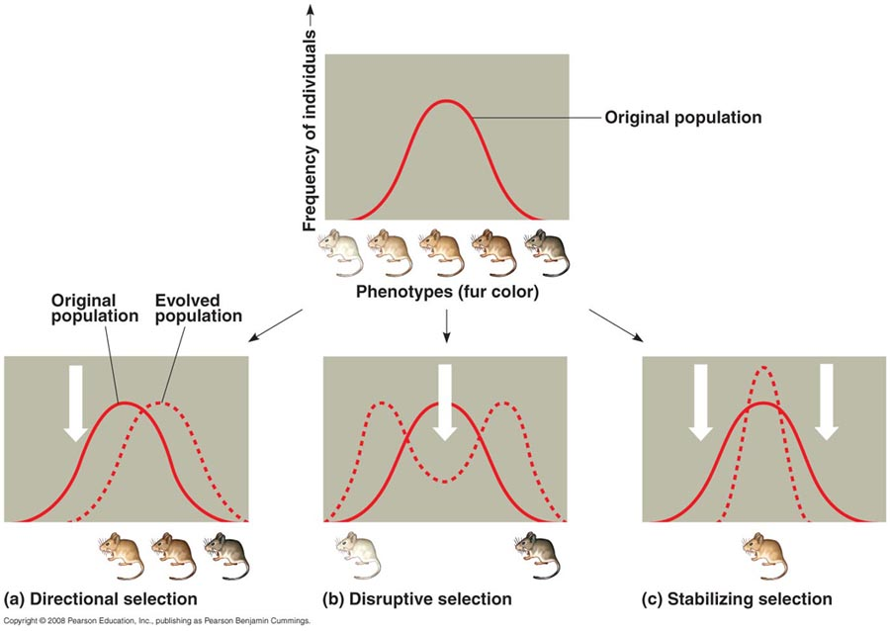

- Speciation – the formation of new species

  - _______________________________ – groups of organisms that are reproductively isolated from other such groups.
    - Defining species is difficult. e.g. In asexually reproducing animals, all individuals are reproductively isolated from each other.
    - Reproductive isolation can be categorized as pre-mating or post-mating.
      - _______________________________isolation may be due to behavioral, geographic or temporal differences in mating patterns or cycles.
      - _______________________________isolation prevents successful fertilization or development after mating, often due to cellular problems during mitosis, or in meiosis of the hybrid (e.g., the mule).
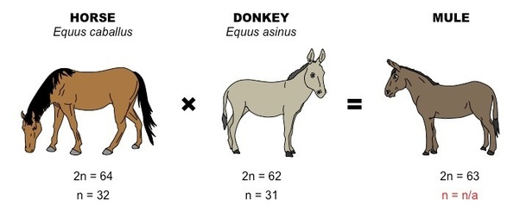

  - There are three modes of speciation, distinguished by the distribution of the initial populations before speciation occurs:
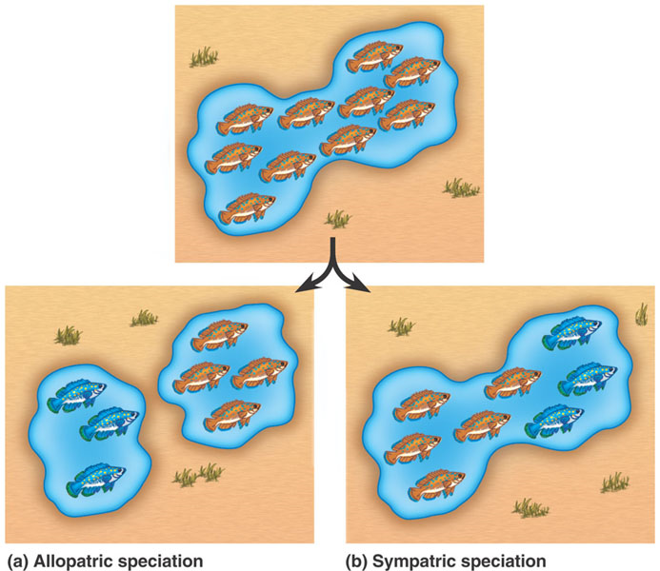
    - _______________________________ speciation is the most common form of speciation and occurs due to geographic separation of populations. The Galapagos finches are a classic example of allopatric speciation, but the text provides new details of this example.
    - ________________________ speciation occurs when demes become reproductively isolated, and is considered to be of minor importance in speciation.
    - ________________________ speciation occurs when organisms within a single population become reproductively isolated, but is rare in animals (more common in polyploid plants)
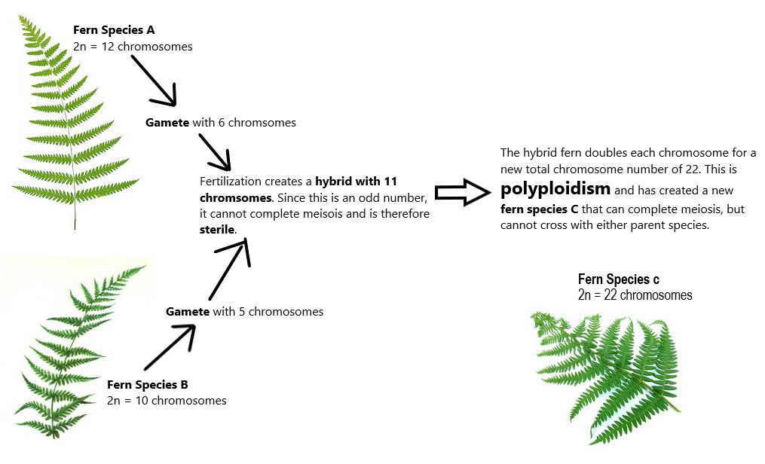

- The Rate of Evolution

  - Darwin saw evolution as a slow steady process, known now as _______________________________

  - Some scientists believe that the evolutionary process is characterized by long periods of stasis, followed by rapid evolution, referred to as the _______________________________.

  - Both models are now considered important in the study of evolutionary rates and relationships.

