Zoology - PSEUDOCOELOMATE ANIMALS – the Aschelminthes

I. Compared and Contrasted to Acoelomate Animals

A. They are like the acoelomate animals in that they…
1. They are bilateral “worms”
2. Cephalization
3. Lack circulatory and respiratory systems

B. They are more complex than the acoelomate animals in that they…
1. They have a pseudocoelom derived from the blastocoel.
2. They are more mobile.
3. They have more complex reproductive systems.
4. They can store wastes for discharge out of the body.
5. They have a complete mouth to anus digestive system

II. What is a pseudocoelom?
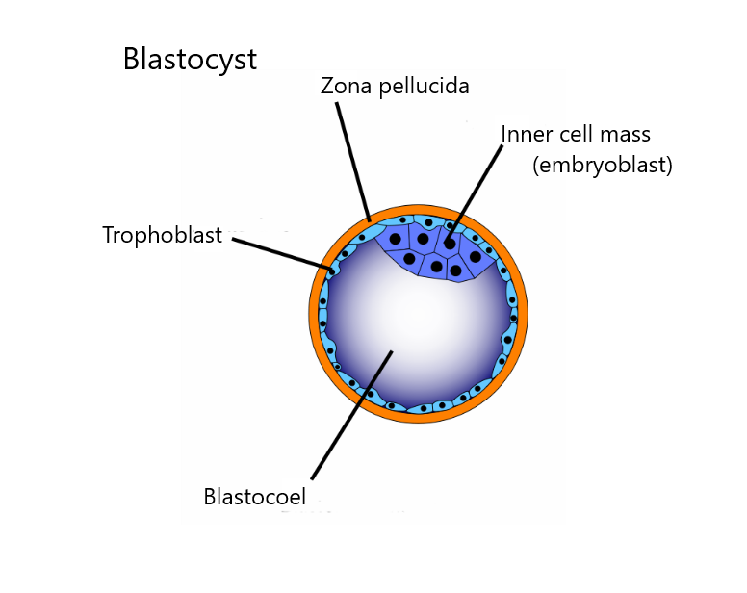
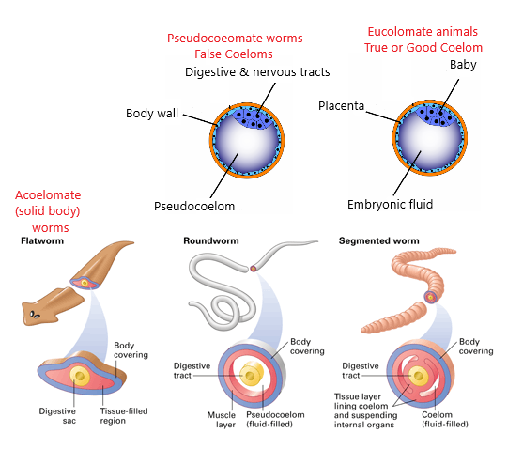

A. Structure
1. The original ______________________ of the embryo persists as a space or cavity between digestive cavity and the body wall. These worms are retaining an embryonic structure as part of their adult body.
2. Since it lacks the peritoneal lining of a true coelom, it is a Pseudocoel
“____________________________________”.

B. Biological Contributions
1. Pseudocoelom generally provides greater freedom of movement.
2. There is space for more development of digestive, excretory, and reproductive
systems.
3. It is simpler to distribute materials throughout the body.
4. This provides a storage area for waste products to be later discharged.
5. As a ______________________ organ, the cavity is a base for muscles that provide
movement.

III. Pseudocoelomates

- A term which refers to animals with a pseudocoelomate body plan is Aschelminthes.
- _____________________________________ -- A heterogeneous phylum of small to microscopic wormlike animals; individuals are pseudocoelomate and mostly unsegmented and are covered with a cuticle.

B. Except in parasitic ______________________, the digestive tract is complete (from mouth to pharynx to intestines to anus).

C. Digestive tract, gonads and excretory organs are within the ___________________.

D. In some, the epidermis secretes a nonliving ______________________.

IV. Lophotrochozoan phyla – the Aschelminthes that do NOT molt
- Phylum Rotifera
- Phylum Acanthocephela

- Phylum Rotifera
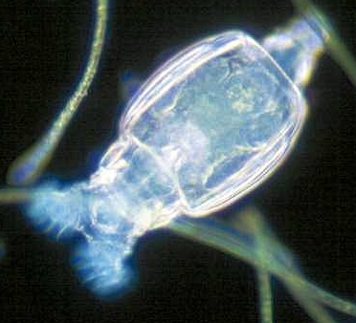
1. Rotifers have a ciliated crown, the ______________ that beats like a rotating wheel.
a. Rotifers are highly diverse in color, size and
shape; some are colonial.
b. Rotifers are found worldwide _____________
distribution) with over 1,800 species known.
c. Most are freshwater species but a few are
_____________________ (living in salt water),
______________________ (living on dry land)
or parasitic.
d. Many endure _____________________ (drying out)
and temperature changes by ___________________.

2. Reproduction
a. Rotifers are usually ______________________
1) Males are smaller than females.
2) In some classes, males are unknown, and in others, males occur only
briefly.
b. Bdelloidea females are ____________________________, producing diploid eggs that hatch into diploid females.
c. Monogononta females produce diploid ______________________ eggs that form diploid females, or haploid ______________________ eggs that, if not fertilized, become haploid males.

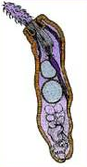
- Phylum Acanthocephala – ___________________________ worms

1. All spiny-headed worms are parasites in the intestines of ________________.
a. Its proboscis has rows of recurved spines that penetrate
and may rupture host intestines.
b. Larvae develop in crustaceans or insects.
c. They never infest humans.

2. Form and Function
a. The body is somewhat flattened.
b. Both longitudinal and circular body wall muscles are present.
c. There is no respiratory system or heart.
d. They lack a digestive tract and absorb all nutrients across the tegument, which bears some enzymes.
e. Shelled embryos discharged in the feces do not hatch until eaten by an
intermediate host, often _____________________.
f. Larval acanthors burrow through beetle intestine and develop into juvenile
cystacanths in the insect hemocoel.

V. The Ecdysozoan phyla – Aschelminthes that do molt
- Phylum Nematoda
  - Roundworms
  - Pinworms
  - Hookworms
  - Trichina worms
  - Filarial worms
- Phylum Nematomorpha

- Phylum Nematoda: ______________________

1. About 12,000 species are described; perhaps a half million exist.
a. They live in virtually all habitats in all biomes; topsoil may contain billions per
acre.
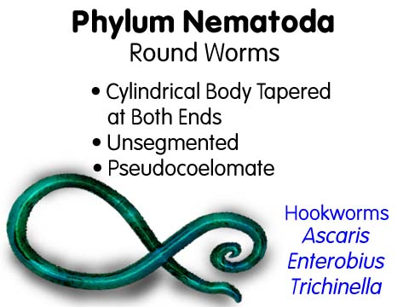
b. Nematode parasites exist in nearly all animal and plant species;
1) They are economically important.
c. Free-living nematodes feed on bacteria,
yeasts, fungal hyphae and algae.
d. Predatory nematodes eat rotifers,
tardigrades, small annelids and other
nematodes.
e. Nematodes are also important as food for
mites, insects, larvae and fungi.

2. Form and Function
a. Distinguishing Characteristics
1) They have a cylindrical shape.
2) They have nonliving cuticle.
3) Muscles in the body wall only run longitudinally.
b. The pseudocoel serves as a hydrostatic skeleton against which longitudinal
muscles work.
c. An outer, thick, noncellular cuticle is secreted by the underlying hypodermis.
d. The cuticle has layers of crisscrossing collagen, providing elasticity but
constraining expansion.
e. Digestion
1) The alimentary canal consists of mouth, pharynx, a non-muscular
intestine, a short rectum and the anus.
f. Reproduction
1) Most nematodes are dioecious with males smaller than females.
2) The male has copulatory spicules to hold the female vulva open
against hydrostatic pressure.
3) Fertilization is internal and eggs are stored in the uterus until deposited.

B. Phylum Nematoda: The Large Roundworm of humans: ________________________
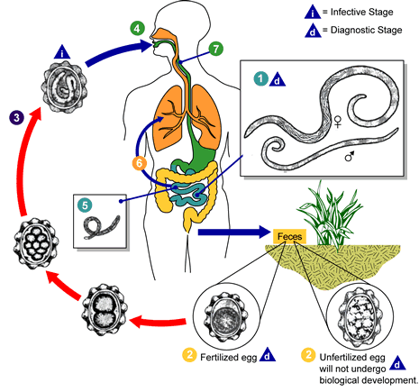
1. Ascaris lumbricoides occurs in up to 64% of people in some areas of the southeastern U.S.
2. More than 1.2 billion are affected worldwide.
3. A female Ascaris lays 200,000 eggs a day, passing out in the host’s __________________.
4. Embryonic development completes in two weeks.
5. Viable eggs remain after signs of fecal matter have disappeared; eggs survive long periods in soil.
6. When a host swallows __________________,
juveniles hatch and burrow through intestinal wall.
7. Carried through the heart to the
_____________________, they break into the
alveoli and are carried up to the tracheae.
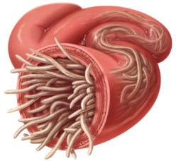
8. Coughed up and swallowed, they mature in the ___________________ two months after they were swallowed.
9. They feed on ______________________ and may block or perforate the intestines.
10. Infection avoidance:

C. Phylum Nematoda: Pinworms: ___________________________

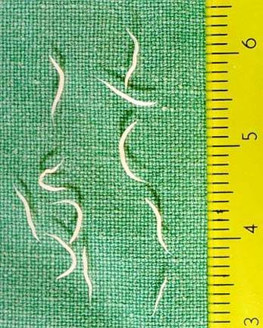
1. It is the most common ______________________ parasite in the U.S. but causes little disease.
2. Adults live in the large intestine and cecum.
3. Females, about 12 mm long, migrate to the anal region at night and lay eggs, causing ____________.
4. Scratching the anal region contaminates hands and bedclothes.
5. Eggs develop rapidly and become infective within six hours at body temperature.
6. When ______________________, they hatch in the duodenum and mature in the large intestine.
7. Members of this order have haploid males from unfertilized eggs; females are diploid and come from fertilized eggs.
8) Infection avoidance:

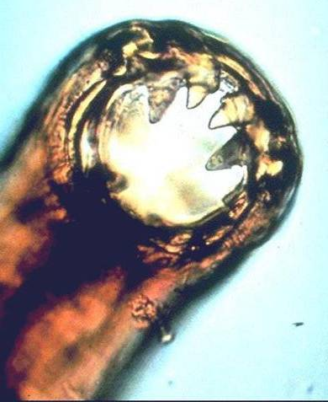
- Phylum Nematoda: Most common human hook worm: ___________________________
1. The anterior end of these small (9-11 mm) worms has a
hook-like curve.
2. The males and females are separate.
3. Large plates in their mouths cut into intestinal mucosa; then
they suck the ___________________.
4. They pump through more blood than they digest;

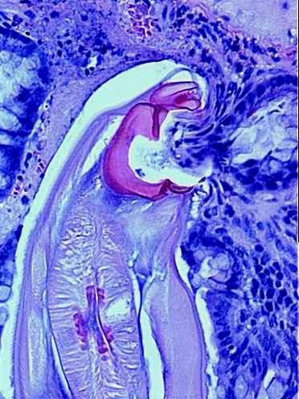
heavy infections cause ______________________.
5. Eggs pass in ______________________ and juveniles hatch in soil
where they live on ______________________.
6. If human skin comes in contact with soil, infective juveniles burrow through ______________________ to ______________________.
7. Similar to Ascaris, they travel in blood to lungs, are coughed up to be swallowed, and mature in the intestine.
8. Infection avoidance:

E. Phylum Nematoda: The Trichina Worm: ___________________________
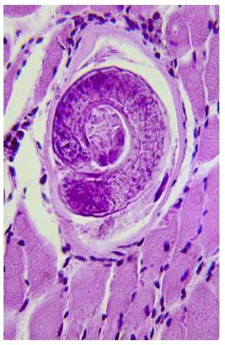
1. While tiny, this worm can cause potentially lethal
______________________.
- Adult worms burrow into the intestinal mucosa and
females directly produce ______________________.
- Juveniles penetrate blood vessels and circulate
throughout the body to all tissues and spaces.
- They penetrate skeletal muscle cells, redirecting gene
expression of the musculature so it loses its striations and becomes a _____________________to the parasite.
- When meat containing live juveniles is eaten, worms are
liberated and mature in the ______________________.
6. They infect humans, hogs, rats, cats and dogs; hogs can
become infected eating uncooked scraps of infected meat or
rats.
7. Heavy infections cause death; about 2.4% of the U.S. population is infected, mostly
lightly.
8. Infection avoidance:

F. Phylum Nematoda: Filarial Worms - Eight species of filarial nematodes infect humans;
some cause major and serious diseases.
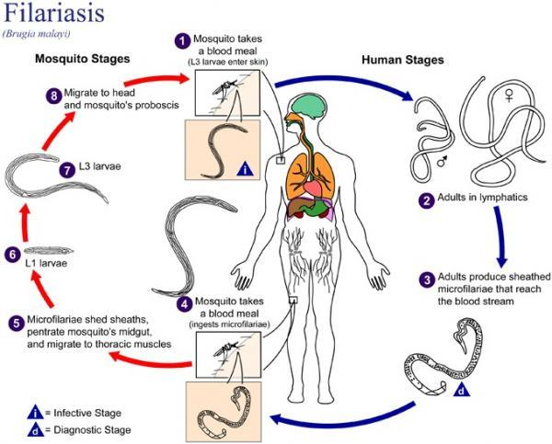
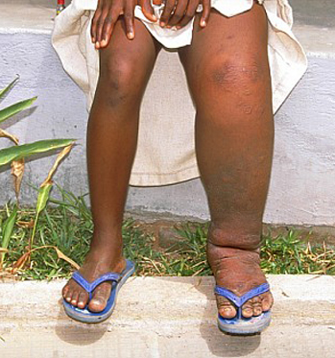
1. Wucheria bancrofti and Brugia malayi live in the ________________ system.
a. The worms cause inflammation and blockage of the lymphatics.
b. Females release live young, tiny ____________________, into
blood and lymph.
c. ______________________ ingest the microfilariae when they
feed; the worms develop to the infective stage and move into
the mosquito bite wound when it feeds.
d. ______________________ is caused by repeated exposure;
swelling and growth of connective tissue causes enormous
swelling of body parts.
2. River blindness or ______________________ is carried by
______________________ and infects 30 million people in tropics.
3. Dog heartworm, ___________________________, is carried by mosquitoes and is
most common U.S. filarial worm.

G. Phylum Nematomorpha – “________________________________”

1. Resemble coarse hairs from a horse’s tail.
a. People believed they spontaneously generated when a horse’s tail fell into
water. The name stuck.
2. Form and Function
a. Adults are free-living in moist habitats; juveniles are parasites of
______________________.
b. They range from 10 to 70 cm long but only 0.3 to 2.5 mm in diameter.
c. Circulatory, respiratory and excretory systems are lacking.
d. Juveniles only emerge from the arthropod host when ___________________
is nearby.
e. Females discharge eggs into water; juveniles hatch and gain entry to the
arthropod host.
f. After months in an arthropod host, the mature worm emerges into nearby water
or during rainfall.
g. Somehow, the parasite stimulates terrestrial insects to seek water.
Watch this video of horsehair worm escaping from a cricket! http://youtu.be/D7r1S6-op8E

C. Phylum Kinorhyncha

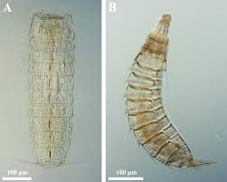
1. Kinorhynchs are small (usually less than 1mm
long) marine animals that feed on
______________________ (a photosynthetic
single celled organism enclosed by a shell of silica).
a. About 75 species are known.
b. They are cosmopolitan.
c. The body is divided into 13 segments with
spines but no cilia.
d. It cannot swim, but anchors in its silt or mud
burrow with spines.
2. Reproduction
a. Sexes are separate with paired gonads and
gonoducts.
b. Development includes a series of six juvenile stages and
a nonmolting adult.

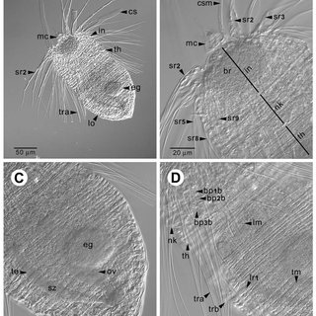
D. Phylum Loricifera

1. Loriciferans were recently discovered (____________________) in spaces between marine grains.
a. They are tiny, less than ¼ mm.
b. They are apparently widely distributed.

E. Phylum Priapulida

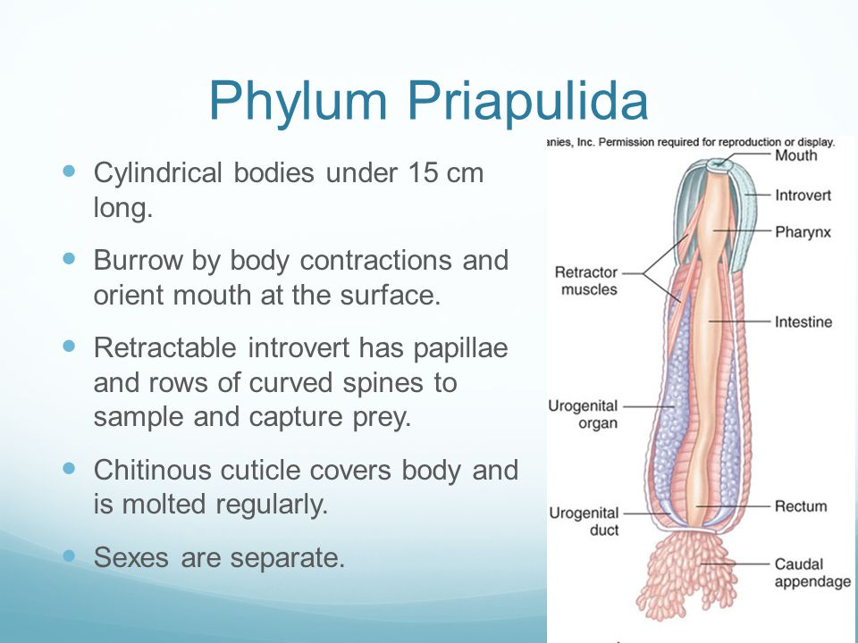
1. 18 species of these marine worms occur in colder waters.
2. Some are tube dwellers and feed on
_________________
(a mass of dead or decaying organic
matter).
3. Priapulids have cylindrical bodies
under 15 cm long.
4. They burrow by body contractions and
orient their mouth at the surface.
5. A chitinous cuticle covers
the body and is molted regularly.

